Table of Contents

CHAPTER ONE 1

1.0 INTRODUCTION 1

1.1 Background of the study 1

1.2 Statement of the problem 2

1.3 Significance of the study 2

1.4 Justification of the study 2

1.5 Aim and Objectives 2

1.6 Scope of the study 2

CHAPTER TWO 3

2.0 LITERATURE REVIEW 3

2.1 Medicinal Plants 3

2.2 Extractions 4

2.3 Secondary metabolites 5

2.4 Current trend in Phytochemistry and Medicinal Plant 10

2.5 Chromatographic analysis 11

2.6 Biological assays 11

CHAPTER THREE 14

3.0 MATERIAL AND METHODS 14

3.1 Materials 14

3.2 Collection of Plant and identification of Plant material 14

3.3 Methods 14

3.4 Preparation of plant extract 15

3.5 Qualitative phytochemical analysis 15

3.6 Microorganisms 16

3.7 Analysis of antidiarrheal activity 16

CHAPTER FOUR 18

4.0 RESULTS 18

4.1.1 Percentage Recovery of Extract 18

4.1.2 Physical Properties of the Plant Extracts 18

4.1.3 Phytochemical screening 18

4.1.4 Identification of the isolates 19

4.1.5 Antibacterial activity of root bark extracts 20

4.1.6 Minimum Inhibitory Concentration (MIC) And Minimum Bactericidal Concentration (MBC) 21

4.1.7 Oral Acute Toxicity Test 22

CHAPTER FIVE 23

5.0 SUMMARY, CONCLUSION AND RECOMMENDATION 23

5.1 Summary 23

5.2 Conclusion 24

5.3 Recommendations 24

REFERENCES 25

# CHAPTER ONE

## 1.0 INTRODUCTION

### 1.1 Background of the study

Frequency of passage of three or more loose or watery stools and unformed feces per day indicates diarrhea. Diarrhea is not a disease, but it may be associated with several diseases like abdominal pain and irritation within the lining of the small or large intestine leads to diarrhea. Decrease in water absorption and increase in loss of water with stools also leads to diarrhea. Loss of fluid in the form of diarrhea causes electrolyte imbalance and dehydration. Food tolerance, food poisoning, intestinal disease, infection (parasitic, bacterial and viral), malnutrition, and sometimes medication factors are responsible for diarrhea (Victora *et al.,* 2000). Plants having medicinal activity are the source of antidiarrheal drugs (Longanga *et al.,* 2000). Medicinal plants are used by almost 80 % of the world’s population for their basic health care because of their low cost and ease in availability (Shahzadi *et al.,* 2010). From the dawn of civilization, people have developed a great interest in plant-based drugs and pharmaceutical products (Shahzadi *et al.,* 2010). In the last few decades, many bacterial organisms have continued to show increasing resistance against current antimicrobial agents (Nascimento *et al.,* 2000). Herbal drugs made from medicinal plants have been used from ancient times to treat various diseases and their antimicrobial properties make them a rich source of many potent drugs (Srivastava *et al.,* 2005). The World Health Organization encourages the scientific study of traditional medicine pertaining prevention and treatment of diarrheal disease. Diarrhea is a major cause of ill health, especially for children because particularly rotavirus responsible for it (Chitme *et al.,* 2004).

*Tamarindus indica* Linn is belonging to the family *Fabaceae*, commonly known as tamarind. It is indigenous to tropical Africa and exotic to Asia and Central America. India and Thailand are the major tamarind world producers and generating 300,000 and 140,000 tons annually, respectively. There are two main types of tamarind: sour (the most common) and sweet (mostly comes from Thailand). Tamarind can be eaten fresh (ripe or unripe) and it can be consumed processed into different products. It grows as a large tree and is found in all medicinal system for a number of diseases, these includes its usefulness in jaundice, in liver, complains, as an acid refrigerant, as a gentle laxative, in yellow fever, as a blood tonic, and as a skin cleanser. It contains invert sugar, citric acid, oleic acid, linoleic acid, volatile oils (geraniol, limonene), pipecolic acid, lupeol, orientin, vitamin B3, vitamin C, vitexin, phenylalanine, leucine, potassium, Campesterol, β-amyrin, β-sitosterol, Tannins, saponins, glycosides. It has various pharmacological activity like hypolipidemic, weight reducing, antidiarrheal, antimicrobial, hepatoprotective, anthelmintic, antioxidant, analgesic & anti-inflammatory etc. This will be helpful to create interest towards Tamarind and in developing new formulations with more therapeutic and economical value (Zohrameena *et al.,* 2017).

### 1.2 Statement of the problem

The worldwide escalation in both community and hospital-acquired antimicrobial-resistant bacteria is threatening the ability to effectively treat patients, emphasizing the need for continued surveillance, prudent infection control, and new treatment alternatives. Therefore, the need to develop efficient and safe drugs from plant sources is of great importance, because continued investigation of plants secondary metabolites has led to important breakthrough in pharmacology and has helped tremendously in the development of modern pharmacotherapeutics in Africa and other parts of the world. Therefore, the increasing rise in demand for the development of new and safe drugs from plants to combat resistance of bacteria towards antibiotics, high mortality and infections caused by disease causing bacteria necessitate this research work.

### 1.3 Significance of the study

The result of the determination will serve as the source of information on the validity usage of the extracts of the root bark of *Tamarindus indica* in the treatment of diarrhea and may also serve as a source of new drugs.

### 1.4 Justification of the study

This research work will be carried out to justify the claim that the root bark of *Tamarindus indica* contains secondary metabolites that can be used in treatment and confirmation of its medicinal value towards diseases associated with diarrhea causing bacteria.

### 1.5 Aim and Objectives

**1.5.1 Aim of the study**

The aim of this research is to evaluate the phytochemical and antidiarrhea activity of the root bark of *Tamarindus indica* in order to establish the scientific basis for its therapeutic properties in folkloric use.

**1.5.2 Objective of the study**

The objectives include:

1. To extract the root bark of the plant with different solvent systems.
2. To study the phytochemical activity of the extracts.
3. To study the antidiarrheal activity of the extracts.
4. Determination of Minimum Inhibitory Concentration (MIC) of the extracts.
5. Determination of Minimum Bactericidal Concentration (MBC) of the extracts.
6. To make appropriate recommendations based on findings.

### 1.6 Scope of the study

The scope of this research work is to carry out phytochemical screening and antidiarrheal activity of the root bark of *Tamarindus indica* within Bauchi metropolice.

# CHAPTER TWO

## 2.0 LITERATURE REVIEW

### 2.1 Medicinal Plants

Medicinal plants have been identified and used throughout human history (Lichterman, 2004). The use of medicinal plants to treat diseases is almost universal amongst non-industrialized societies and is often more affordable than purchasing expensive conventional drugs (Fabricant and Farnsworth, 2001). The world Health Organization (WHO) estimates that 80% of the world population especially Asian and African countries use herbal medicine for some aspect of primary health care (<http://www.traffic.org/medicinalplants>, 30th march, 2014). Over 120 active compounds currently *isolated* from the higher plants are widely used in modern medicine and 80 % of these show a positive correlation between their modern-day therapeutic use and the traditional use of the plants from which they are derived (Fabricant and Farnsworth, 2001).

**2.1.1 *Tamarindus indica***

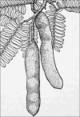 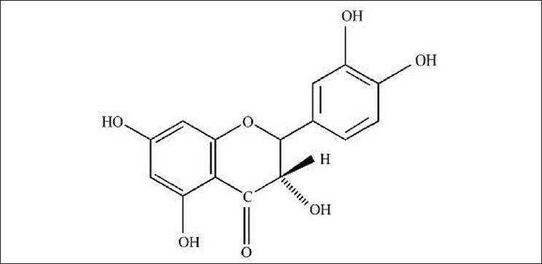

Plate1: Tamarindus indica. Fig 1: Epicatechin.

Tamarindus indica is of moderate to large in size, evergreen tree, up to 24 m in height and 7m in girth. The latest morphologic and molecular analyses and continued study will clarify the exact positioning of Tamarindus in relation to its putatively related genera (Leonard *et al,* 1990). It is a large evergreen tree with an exceptionally beautiful spreading crown, and is cultivated throughout almost the whole country, except in the Himalayas and western dry regions. Leaves alternate, compound, with 10-18 pairs of opposite leaflets; leaflets narrowly oblong, 12-32×3-11 mm, petiole and rachis finely haired, midrib and net veining more or less conspicuous on both surfaces. Flowers attractive pale yellow or pinkish, in small, lax spikes about 2.5 cm in width. Flower buds completely enclosed by 2 bracteoles, which fall very early; sepals 4, petals 5, the upper 3 well developed, the lower 2 minutes. Fruit is a pod, indehiscent, subcylindrical, 10-18 ×4 cm, straight or curved, velvety, rusty-brown; the shell of the pod is brittle and the seeds are embedded in a sticky edible pulp. Seeds are 3-10, approximately 1.6 cm long, irregularly shaped, and testa hard, shiny, and smooth.

In India, Tamarind is known by a wide variety of vernacular names: Tetuli (Assamese); Amli, Nuli, Textili Tentul (Bengali); Amali, Ambali (Gujarati); Ambli, Amli, Imli, (Hindi); Puli (Malayalam); Amli, Chinch, Chitz (Marathi); Koya, Tentuli (Oriya); Imli (Punjabi); Chinta (Telugu). (Mishra *et al.,* 1997). In Nigeria, it is known as Tsamiya (Hausa), Awin (Yoruba) and Icheku (Igbo).

T. indica contains high levels of crude protein. T. indica also contains a high level of protein with many essential amino acids, which help to build strong and efficient muscles T. indica is also high in carbohydrate, which provides energy, and is rich in minerals, such potassium, phosphorus, calcium, and magnesium. T. indica can also provide smaller amounts of iron and vitamin A. The whole plant of Tamarind is uesd extensively for medicinal and industrial purpose, hence it is very beneficial to the human being (Morton, 1958).

### 2.2 Extractions

The plant material is extracted and the extract is evaporated and concentrated. The dry extract is subjected to chromatography or other appropriate purification methods to separate the refined extract.

Extraction in chemistry is a separation process consisting in the separation of a substance from a matrix. It includes Liquid-liquid extraction, and Solid phase extraction. The distribution of a solute between two phases is an equilibrium condition described by partition theory. This is based on exactly how the analyte move from the water into an organic layer (Wikipedia, 2019).

**2.2.1 Types of extraction**

There exist several types of extraction, including: liquid–liquid extraction, solid-phase extraction, and acid-base extraction. In liquid-liquid extraction compounds separate according to their relative solubility in two different immiscible liquid phases. This technique has been applied in several fields such as analytical chemistry and biology (Liquid-Liquid Extraction Chemistry, 2013). A Soxhlet extractor is a kind of laboratory equipment. It is made of glass. Franz von Soxhlet invented it in 1879. It has a flask, an extraction chamber, and a condenser. It can be used for solid-liquid extractions. Cold water extraction (also called CWE) is the process whereby a substance is extracted from a mixture via cold water. It is a type of fractional crystallization. The process generally involves taking a mixture of substances, dissolving them in warm water, and then rapidly cooling the mixture (Wikipedia, 2019).

**2.2.2 Components of an extractive process**

Extractions often use two immiscible phases to separate a solute from one phase into the other. Typical lab extractions are of organic compounds out of an aqueous phase and into an organic phase. Common extractants are arranged from ethyl acetate to water (ethyl acetate < acetone < ethanol < methanol < acetone:water (7:3) < ethanol:water (8:2) < methanol:water (8:2) < water) in increasing order of polarity according to the Hildebrand solubility parameter . The extract can be put back to dried form using a centrifugal evaporator or a freeze-drier.

### 2.3 Secondary metabolites

Secondary plant metabolites (Phytochemicals) have been extensively investigated as a source of medicinal agents (Krishnaraju, 2005). Plants can synthesize and accumulate a great variety of phytochemicals in their cells including saponins, tannins, flavonoids, cyanogenic, phenolic compounds, lignins, lignans, alkaloids and glycosides (Okwu, 2004). Plants also have a great potency of antimicrobial activity due to the presence of phenolic compounds and essential oils (Aboaba and Efuwape, 2001). Medicinal plants have been known to produce an array of phytochemicals with recognized antibacterial activity belonging to chemical structural classes: phenolics, terpenoids, alkaloids, lectins, polypeptides, and polyacetylenes but the most bioactive constituents are alkaloids, tannins, flavonoids, and phenolic compounds (Hill, 1995). The screening of plant extracts and plant products for antimicrobial activity has shown that higher plants represent a potential source of novel antibiotic prototypes (Afolayan, 2003). Numerous studies have identified compounds within herbal plants that are effective antibiotics (Afolayan, 2003). Some of the commonly used traditional remedies have already produced compounds that are effective against antibiotic-resistant strains of bacteria (Kone *et al.,* 2004).

**2.3.1 Tannins**

Tannin is astringeny vegetable product found in a wide range of plants parts ranging from the barks, roots, fruits, leaves, galls and roots (Ramakrshnan, 2006). They occur naturally In plants and are water soluble phenolic compounds of the higher molecular weight of about 500 – 3000 containing phenolic

Hydroxyl groups that make them to effectively cross-link with proteins and other macromolecules (Ramkrishnan, 2006).

Tannins are generally found in plants and they are thought to function as chemical defenses against pathogens and herbivores (Gedir *et al.,* 2005). They have been commercially used primarily in the preservation of leather, making glue stains and mordant (Kanth *et al*., 2009). It has also been used in the vegetable industry in different concentration in picking process to provide protection against bacteria, mold, and yeasts (Andrade *et al*., 2005). Antimicrobial activity of tannins has been tested in various fields of medicine providing positive results such as antioxidant activities, anticarcinogenic activities and antimutagenic properties (Lopes *et al.,* 1999). Tannins have been used in inhibiting the growth of many fungi, yeasts, bacteria and viruses (Chung *et al.,* 1998). Studies carried out have shown that tannins such as catechin and pyrogallol found in vegetable tannins have been found to be toxic to microorganisms (Cowan, 1999). Tannins have been found not only effective against pathogenic microbes but also have a significant value as a cytotoxic and an antitumor agent (Josh *et al.,* 2013).

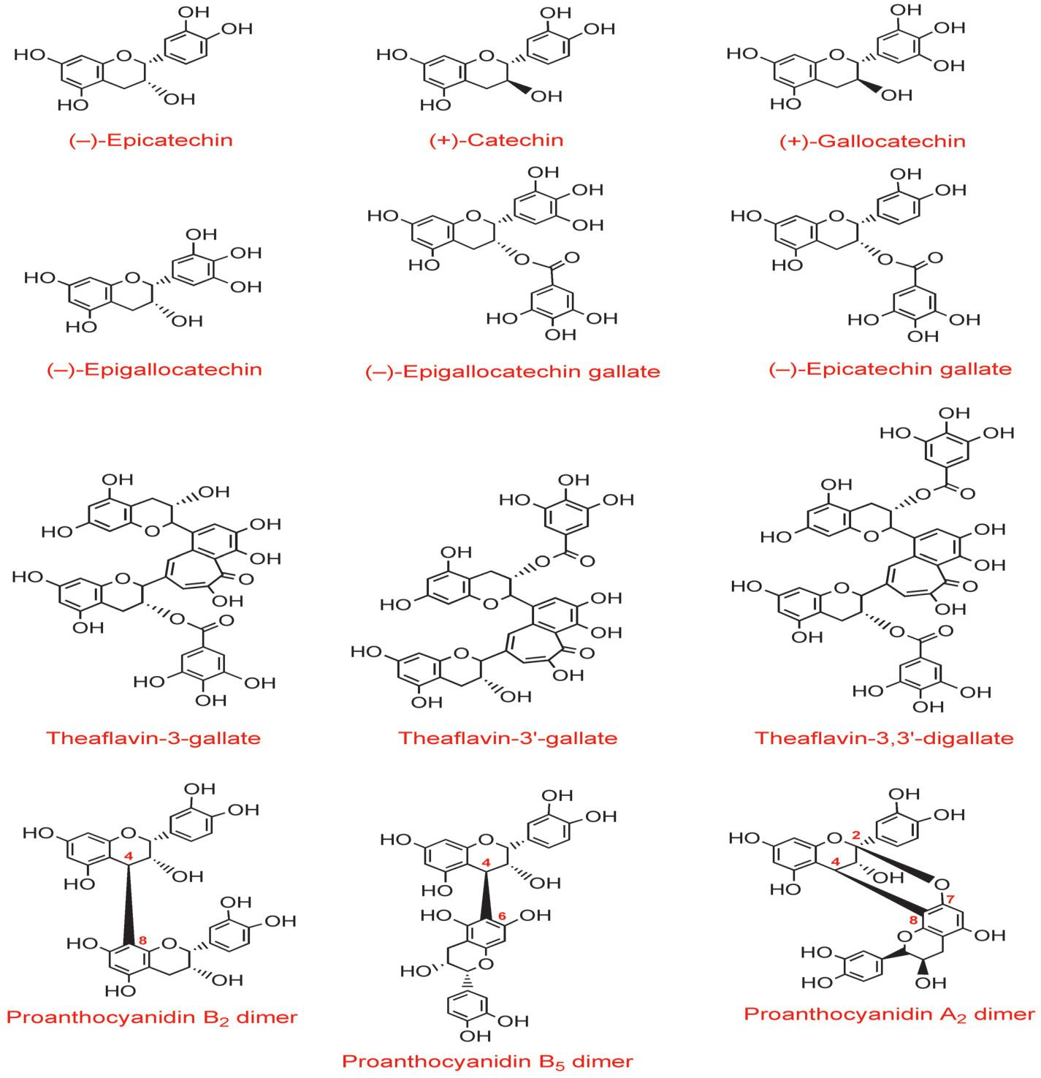

**Fig 2: Structures of Tannins**

**2.3.2 Flavonoids**

Flavonoids or bioflavonoids are secondary metabolites of plants that chemically have a general structure of 15 carbon skeleton consisting of two phenyl rings and a heterocyclic ring (Mc Naught, 1997). There are over 500 groups of flavonoids that have been characterized from various plants according to their chemical structure (Ververidis *et al.,* 2007). They are usually subdivided into anthoxanthins, flavanones, flavanols, flavans, and anthocyanidin (Zhao *et al.,* 2012). In plants they are responsible for floral pigmentation, ultraviolet ray’s filtration in higher plants and symbiotic nitrogen fixation (Galoetti *et al.,* 2008). They are also known to have inhibitory activities against organisms that cause plant diseases for example *Fusarium oxysporum* (Galoetti *et al.,* 2008). Flavonoids have been known to possess antimicrobial activity against bacterial, fungal and viral microorganisms (Cowan, 1999). They are usually known for their antimicrobial activity of inhibiting the synthesis of the nucleic acids, tampering with the integrity of the cytoplasmic membrane function and the energy metabolism process (Cushnie and Lamb, 2005). Flavonoids from some medicinal plants have been found to inhibit the synthesis of the nucleic acids, cause permeability of the inner bacterial membrane and a dissipation of the membrane potential of Gram negative and Gram-positive bacteria (Cushnie and Lamb, 2005). Some of the bioactive components have been isolated from flavonoids have been found to contain antifungal, antibacterial and insecticidal activities (Abdel *et al., 2013*). Previous studies carried out have shown that when mixed with antibiotics they have synergistic activity and suppress many pathogenic microorganisms in numerous in vitro and in vivo studies (Cushnie and Lamb, 2011; Manner *et al*., 2013). Additional in vivo studies have shown that flavonoids can be used as pharmaceutical drugs for bacterial infections or through the dietary intake to offer protection against infection (Zamora *et al.,* 2012).

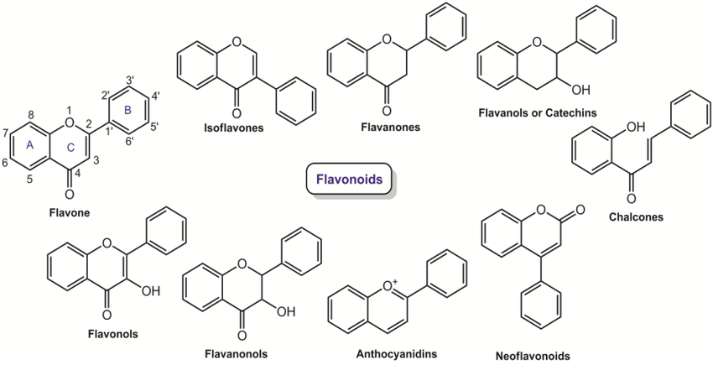

**Fig 3: Structures of Flavonoids**

**2.3.3 Alkaloids**

They are a group of naturally occurring compounds that contain nitrogen and can be neutral or have weakly acidic properties (Mc Naught, 1997). They may also sometimes contain oxygen, Sulphur, more rarely other elements such as chlorine, bromine, and phosphorus (Schardl *et al.,* 2007). They are mainly secondary metabolites of plants but can also be produced by a variety of organisms including bacteria, fungi, and animals (Kittakoop *et al.,* 2014). They dissolve in water poorly but readily dissolve in organic solvents (Shi *et al.,* 2014). They are divided into five major groups namely: true alkaloids (contain nitrogen in heterocyclic and originate from amino acids), proto alkaloids, polyamine alkaloids, peptide and cyclopeptides alkaloids and pseudoalkaloids (Faulkner *et al.,* 2006). They have a wide range of pharmacological activities such as antiasthma, antimalarial, anticancer, cholinomimetic, vasodilatory, antiamyhyrithic, analgesic, antibacterial and antihyperglycemic activities (Cushnie and Lamb, 2014). Some alkaloids have been known to possess psychotropic and stimulant activities and have been used as recreational drugs and entheogenic rituals (Blankenship *et al.,* 2005). Alkaloids have great antimicrobial activity against bacterial pathogens such as *Escherichia coli, Klebsiella pneumonia, Staphylococcus aureus* and *Pseudomonas aureginosa* (Maatalah *et al*., 2012).

Some of the bioactive components of alkaloids such as morphine and cordine have been found to be active not only against bacterial and fungal pathogens but also trypanosomes and plasmodia (Feiburghaus *et al.,* 1996; Omulokoli *et al.,* 1997). Some of the Alkaloids found in dietary food materials have also been found to contain microbiocidal and antidiarrheal effect in the small intestine where they show the ability to intercalate with the microbial genetic material (Ghoshal *et al.,* 1996; Phillipson and Niell, 1997). Other studies carried out on alkaloids extracted from a variety of medicinal plants in Nigeria showed a great antifungal activity (Garba and Okeniyi, 2012).

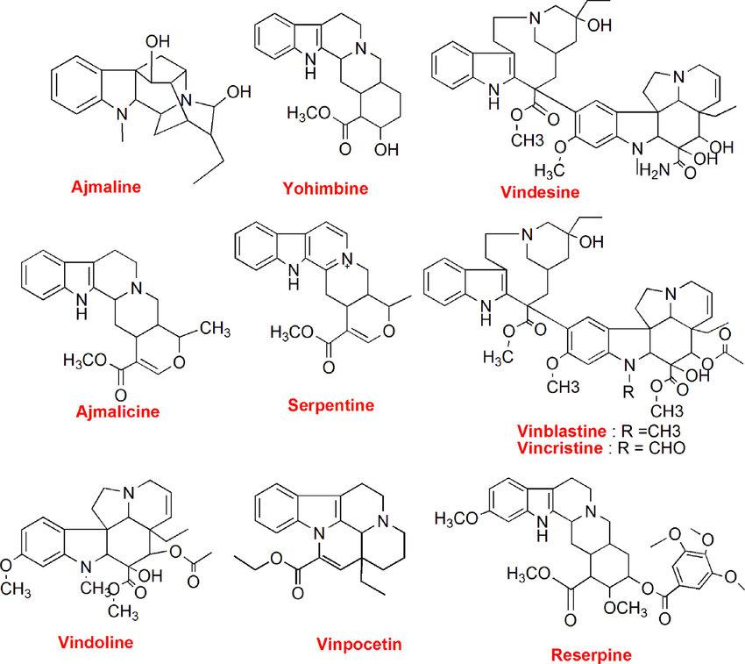

**Fig 4: Structures of Alkaloids**

**2.3.4 Saponins**

They are a class of chemical compounds found in various plant species and they are amphipathic glycoside grouped structurally by having one or more hydrophilic glycosides moieties combined with liphophilic triterpene (Hostettmann and Martson, 1995). In plants, saponins are known to provide protection against microbes and fungi (Riguera, 1997). Saponins have been used by a wide range of commercial therapeutic claims for natural products whereby in organismal or human benefit are often based on preliminary biochemical and cell biology studies (Skene and Phillip, 2006). Saponins are also considered as one of the natural antimicrobial products that make up the defense system of the plants and some can be beneficial rather than harmful to animals (Rupasinghe *et al.,* 2003; Hubert *et al.,* 2005).

There has been evidence of the presence of saponins in traditional medicine preparations where the administration is through oral means that is expected to lead to the hydrolysis of glycosides from terponoids (Asl *et al.,* 2008). Studies carried out have shown medicinal plant extracts fractions rich in saponins are effective against microorganisms such as *Escherichia coli, Salmonella typhi, Aeromonas hydrophilia* and other fungal pathogens such as *Candida albicans* (Deshpande *et al.,* 2013). Saponins antimicrobial activity is attributed mainly to its capability of lysing microorganism’s membranes rather than the surface tension of the extracellular medium (Asl, 2008). Apart from antimicrobial activity, saponins have shown other biological properties with its cytotoxic activity on cancer or tumor cells being considered the most important one (Yokosuka and Mimaki, 2009). Other plants are known to produce steroidal saponins for example cholestane glycosides which are known to have a broad spectrum of biological activities such as cytotoxic activity, antifungal, antibacterial and in vivo antitumor activities (Li *et al.,* 2012).

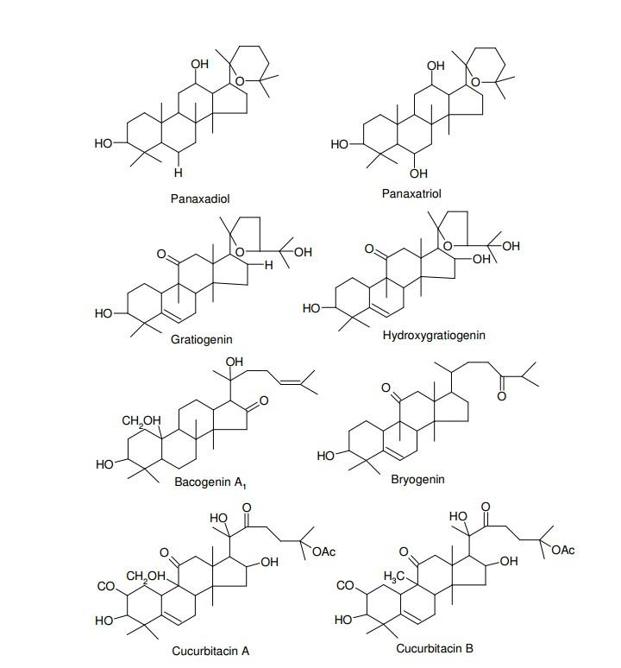

**Fig 4: Structures of Saponins**

### 2.4 Current trend in Phytochemistry and Medicinal Plant

Synthesis of secondary metabolites by plants is often with highly complex structures. Most of these important secondary metabo

lites are obtained from wild or cultivated plants because their chemical synthesis is not economically feasible. Various biotechnological methods have been employed in producing some of the secondary metabolites of plants through plant cell cultures. However, this has had limited success because of lack of understanding of how these metabolites are synthesized. State-of-the art genomic tools, however, can be used to enhance the production of known target metabolites or to synthesis entire novel compounds by so-called combinatory biochemistry in cultivated plant cells (Oksman-Caldenteya and Inzé, 2004). Some plant cells have been used as factories to produce some secondary metabolites. Examples of these are paclitaxel, an anti-cancer drug originally extracted from the bark of 50-60-year-old Pacific yew trees (*Texus brevifolia*); shikonin, produced by cell suspension cultures of *Lithospermumerythrorhizon;* berberine, produced by cell cultures of *Coptis japonica;* rosmarinic acid, produced by cell cultures of *Coleus blumeli,* which has been achieved on a large scale, and sanguinarine, produced by cell cultures of *Papaversomniferum,* which has market potential in oral hygiene products (Oksman-Caldenteya and Inzé, 2004) .

### 2.5 Chromatographic analysis

Chromatography is a laboratory technique for the separation of a mixture. The mixture is dissolved in a fluid called the mobile phase, which carries it through a structure holding another material called the stationary phase. The various constituents of the mixture travel at different speeds, causing them to separate. The separation is based on differential partitioning between the mobile and stationary phases. Subtle differences in a compound's partition coefficient result in differential retention on the stationary phase and thus affect the separation (McMurry and John, 2011). Chromatography may be preparative or analytical. The purpose of preparative chromatography is to separate the components of a mixture for later use, and is thus a form of purification. Analytical chromatography is done normally with smaller amounts of material and is for establishing the presence or measuring the relative proportions of analytes in a mixture. The two are not mutually exclusive (Hostettmann *et al.,* 1998).

### 2.6 Biological assays

**2.6.1 Anti-fungal activity**

Tamarind fruits are reported to have anti-fungal as well as anti-bacterial proper- ties (Ray & Majumdar (1976), Guerin and Reveillere (1984), Bibitha *et al.* (2002), Metwali (2003) and John *et al.* (2004) all cited in El-Siddig *et al.*, 2006). Extracts from the fruit appear promising as a potential fungicidal agent against cultures of *Aspergillus niger* and *Candida albicans* (El-Siddig *et al.*, 1999; El-Siddig *et al.*, 2006).

**2.6.2 Antidiarrhea activity**

Other important disorders treated by tamarind include diarrhea and dysentery. Dysentery is a kind of diarrhea containing mucus or blood, usually caused by an infection of the intestine. When diarrhea is not treated accurately, the patient risks dehydration and death. In tropical countries, diarrhea is one of the major health problems and frequently occurs during rainy weather (Heinrich, 1998 cited in Gutiérrez *et al*., 2008). There appears to be a striking dissimilarity between West and East Africa in the treatment of diarrhea. For West Africa, literature only mentions the use of the bark. It can be applied as a decoction (Dalziel, 1937; Kerharo and Bouquet, 1950a; Traoré, 1983; Keita and Coppo, 1993), pulped with lemon (Kerharo and Bouquet, 1950a) or macerated in milk (Keita and Coppo, 1993). In East Africa, it is not the bark but the leaf that is used, made into a juice or beverage (Haerdi, 1964; Chhabra *et al*., 1987) or prepared in a concoction with Sterculia africana (Kokwaro, 1976). In Kenya the use of ground seeds has been recorded (Simitu and Oginosako, 2005) and in Tanzania the root is used to treat dysentery (Chhabra *et al*., 1987).

**2.6.3 Anti-viral activity**

Plant extracts of tamarind were reported to have antiviral activity on watermelon mosaic viruses (Chapman (1984) cited in El-Siddig *et al.*, 1999), cow pea mosaic viruses (Singh *et al.* (1989) cited in El-Siddig *et al.*, 1999) and tobacco mosaic viruses (Stovakova *et al.* (1994) cited in El-Siddig *et al.*, 1999).

**2.6.4 Antioxidant activity**

Tamarind seed kernels have a relatively high antioxidant activity and phenolic con- tent (Soong *et al.*, 2004). Four anti-oxidative compounds were isolated and identified from the seed coats: phenolic antioxidants, such as 2-hydroxy-3’, 4’-dihydroxyacetophenone, methyl 3,4-dihydroxybenzoate, 3,4-dihydroxyphenyl acetate and epicatechin (Tsuda *et al.*, 2004). These antioxidants may be used for increasing shelf life of food products and improving the stability of lipids and lipid-containing foods by preventing loss of sen- sory and nutritional quality by preventing lipid peroxidation. These compounds may also find a place as food additives though studies are needed to evaluate their effectiveness within food matrices. Extracts exhibit antioxidant potential by reducing lipid peroxida- tion *in vitro* (Tsuda *et al.*, 2004; Tsuda *et al.* (1993) cited in Sudjaroen *et al.*, 2005). Raw and dry heated tamarind seed coats exhibit good antioxidant activity against the linoleic acid emulsion system and the values were lower and higher than the synthetic antioxidant, butylated-hydroxy-anisole (BHA), and ascorbic acid, respectively (Siddhuraju, 2007).

Phenolic plant compounds may have many biologic effects in terms of health pro- motion. An important protective effect is reduction of oxidative damage, mediated by lipid peroxidation, which in living systems is strongly associated with mutagenesis, car- cinogenesis, ageing, and atherosclerosis (Tsuda *et al.*, 2004; Yagi (1987) and Cultar (1984 and 1992) all cited in Sudjaroen *et al.*, 2005). Pumthong (1999), cited in Sudjaroen *et al.* (2005), described the antioxidant activity of extracts of tamarind pericarp, and reported the presence of mainly polymeric tannins and oligomeric procyanidins but the latter were not yet identified or quantified. The anti-oxidative activity of tamarind seed was also investigated by Osawa *et al.* (1994, cited in El-Siddig *et al.*, 2006). They found that ethanol and ethyl acetate extracts prepared from the seed coat exhibited anti-oxidative activity. This suggests that tamarind seed coats, a by-product of the tamarind gum industry, may have potential as a low cost *source* of antioxidants (Tsuda *et al.*, 2004), but we note that so many plants and plant extracts show anti-oxidative activity (Ramos *et al.* (2003) cited in El-Siddig *et al.*, 2006).

**2.6.5 Cytotoxicity assay**

Al-Fatimi et al., reported that methanolic extracts of *Tamarindus indica* showed remarkable cytotoxic activity against FL-cells, a human amniotic epithelial cell line, with IC50 values below (Al-Fatimi *et al.,* 2007). Sano M et al., examined the carcinogenic potential of tamarind seed polysaccharide in both sexes of B6C3F1 mice. The results demonstrated that its polysaccharide is not carcinogenic in B6C3F1 mice of either sex. Bioassay-guided fractionation of methanolic extract of tamarind seeds led to the isolation of L- di-n-butyl maleate which is having pronounced cytotoxic activity against sea urchin embryo cells (Sano M *et al*., 1996). In order to study structure-activity relationships of its analogs, L-di-n-pentyl maleate was the most effective inhibitor to the development of the fertilized sea urchin eggs, and significant inhibitory activity was not in the esters of D-isomer (Kobayashi *et al.,* 1996).

# CHAPTER THREE

## 3.0 MATERIAL AND METHODS

### 3.1 Materials

**3.1.1 Equipment / instruments**

Rotary shaker, rotary evaporator, Whatman filter paper No.1, weighing balance, separatory funnel, glass rod, test-tubes, test-tube rack, conical flasks and other necessary laboratory apparatus.

**3.1.2 Reagents and solvents**

The reagents that would be use for the extraction includes; Methanol and Distilled water. Other chemicals are Dimethylsulphoxide (DMSO), ammonia solution, ferric chloride, sulphuric acid, potassium iodide, acetic acid, hydrochloric acid, acetic anhydride, chloroform, distilled water, and ascorbic Acid.

**3.1.3 Preparation of Reagents**

**3****.****1.3.1 Preparation of Meyer’s Reagent**

In the preparation of this reagent, a 1.36g of mercury (ii) chloride (HgCl2) was weighed and dissolved in about 40 cm3 of distilled water, a 5.0 g of potassium iodide was also weighed and dissolved in about 20 cm3 of distilled water. These two solutions were then mixed in a 100 cm3 volumetric flask and the volume was made up to the mark with distilled water.

**3.1.3.2 Preparation of 5 % w/v Ferric chloride solution**

A 5 % ferric chloride solution was prepared by weighing 5.0 g of ferric chloride, FeCl3 and dissolving in a small quantity of water transferred quantitatively into 100 cm3 volumetric flask and was made up to volume with distilled water.

**3****.****1.3.3 Preparation of 1% v/v Hydrochloric acid**

A 1.0 cm3 of concentration HCl was measured and dissolved in about 100 cm3 volumetric flask and made up to mark with distilled water.

### 3.2 Collection of Plant and identification of Plant material

Root barks of *Tamarindus indica* L. was collected from the roots branching out from the main root at the botanical garden Abubakar Tafawa Balewa University, Bauchi., and the identification of the plant was authenticated by a professional botanist in the Department of Biological Sciences, Faculty of Science, Abubakar Tafawa Balewa University, Bauchi. The root barks were cut into small pieces, air dried, powdered and stored in airtight containers till use.

### 3.3 Methods

**3.3.1 Grinding and Extraction**

The root bark was washed thoroughly thrice with distilled water, air dried for three weeks. The fine powder was obtained from the plant material using laboratory mortar and pestle. About 100 g of the powdered plant material was macerated in 500 ml of distilled water and methanol (100 %) respectively for 48 hours at room temperature as described by (Okoli *et al.,* 2004). Each preparation was filtered through a Whatman filter paper and the aqueous filtrate was evaporated to dryness in water bath at 40°C while methanol extract in rotary evaporator at 50 °Cto obtain a crude methanol fraction (CF). The extraction yield was determined.

### 3.4 Preparation of plant extract

**3.4.1 Stock solution**

The extracts (200 mg) each was weighed and dissolved in a beaker containing small amount of water and then quantitatively transferred into 100ml volumetric flask and made up to volume with distilled water. The resulting solution has a concentration of 2 mg/ml.

**3.4.2 Serial dilution of the extracts**

The stock solutions (1 ml) each was measured and transferred quantitatively into a 100 ml volumetric flask and made up to volume with distilled water. The resulting solutions each have a concentration of 0.02 mg/ml (20 µg/ml).

### 3.5 Qualitative phytochemical analysis

The presence of saponins, tannins, flavonoids and alkaloids in the crude extract will be determined according to the method defined by (Congesta *et al*., 2005).

**3.5.1 Tannins**

Each of the extracts will be weighed to 0.5 mg and dissolved in 1 ml of distilled water. Filtration will be carried out after 2 ml of FeCl3 will be added. If there is presence of a blue or black precipitate then it indicates the presence of tannins.

**3.5.2 Flavonoids**

Each of the extracts will be weighed to 0.5 mg and dissolved in 1 ml of ethanol and filtered. 2 ml of 1% HCl and magnesium ribbon will be added to the filtrate. If there is formation of a pink or red colour it indicates the presence of flavonoids.

**3.5.3 Alkaloids**

Each of the extracts will be weighed to 0.5 mg and dissolved in 1 ml of methanol and filtered. 1 % HCl will be added to the filtrate and the solution heated. Meyer’s reagent will be added dropwise and if there is formation of any colored precipitate it indicates the presence of alkaloids.

**3.5.4 Saponins**

Each of the extracts will be weighed to 0.5 mg and dissolved in 1 ml of methanol and filtered. Distilled water will be added and shaking done for a few minutes. If there is persistence frothing then it indicates the presence of saponins.

**3.5.5 Phenols**

A fraction of the extract will be treated with aqueous 5 % ferric chloride solution. The formation of deep blue or black color indicates the presence of phenols (Solomon *et al.,* 2013).

**3.5.6 Test for Steroids**

To 1 cm3 of each of the extracts 2 cm3 of each chloroform and a few drops of concentrated sulphuric acid were added sidewise. A red colour produced in the lower chloroform layer indicated the presence of steroids.

### 3.6 Microorganisms

**3.6.1 *Escherichia coli***

Acute watery diarrhea; cause of nearly half of cases of traveler’s diarrhea, important cause of diarrhea in children in developing regions; growing cause of foodborne disease in the United States. Diagnostic evaluation involves stool culture for E. coli, followed by assay for heat-labile cholera-like enterotoxin and heat-stable enterotoxins by ELISA, DNA hybridization, or PCR methods

**3.6.2 *Shigella***

Severe diarrhea, often with fever or dysenteric characteristics, with high risk of person-to-person spread due to low inoculum required for infection Conventional stool culture

### 3.7 Analysis of antidiarrheal activity

**3.7.1 Preparation of sample extract for microbiological assay**

0.1 g of each *Tamarindus indica* extract were dissolved using 1 ml of Dimethylsulphoxide (DMSO) to produce 100 mg/ml of the extract from which various concentrations of 50, 40, 30, 20 and 10mg/ml were produced (Ali *et al.,* 2017).

**3.7.2 Antibacterial activity of the extract**

The sensitivity of each extracts was determined using the agar well diffusion method as described by (Ahmed and Beg, 2001) with modifications. The prepared bacterial suspension equivalent to 0.5 McFarland Standard (1.5 x 106 CFU) was inoculated into sterile Mueller- Hinton agar medium in a sterile Petri-dish and rotated at 60° to ensure and even distribution of the inoculums. A sterile 6 mm diameter sterile cork borer was used to bore 6 wells into the agar medium. The wells were then filled up with approximately 0.1 ml of the extract solution at a concentration of 10, 20, 30, 40 and 50 mg/ml taking care to prevent spillage onto the surface of the agar medium. The plates were rotated allowed to stand on the laboratory bench for 1 hour to allow proper diffusion of the extract into the medium after which the plates were incubated at 37 °C for 24 hours, and thereafter the plates were observed for zones of inhibition and measured. The experiment was conducted in triplicate and the average values were recorded. Ciprofloxacin 50 mg/ml (Micro Lab limited) was served as a control (positive) for the experiment.

**3.7.3 Determination of Minimum Inhibitory Concentration (MIC)**

The minimum inhibitory concentration MIC of the extracts was determined using broth dilution technique. Double fold serial dilutions of the extracts were prepared by adding 2 ml of 100 mg/mL of the extract into a test tube containing 2 mL of Nutrient broth, thus producing solution containing 50 mg/ml of the extract. The process continues serially up to test tube No. 5, hence producing the following concentrations; 50, 25, 12.5, 6.25 3.125 mg/mL. Test tube No. 6 do not contain extracts and serve as negative control. Exactly 0.5 ml of 0.5 McFarland equivalent standards of test organisms were introduced into the test tubes and incubated at 37 °C for 24 hours. After incubation the test tubes were observed for growth by checking for turbidity (Ahmed *et al,* 2001).

**3.7.4 Determination of Minimum Bactericidal Concentration (MBC)**

Nutrient agar plates were inoculated with sample from each of the tubes that show no turbidity and the plates were incubated at 37°C for 24 h. The highest dilution that yielded no bacterial colony was taken as the MBC (NCCLS, 2008).

# CHAPTER FOUR

## 4.0 RESULTS

### 4.1.1 Percentage Recovery of Extract

Recovery value of each extracts was calculated as:

% Recovery = Extract Obtained × 100

Weight of the plant material

The Table 1 shows the percentage recovery of the extracts of *Tamarindus indica*. From the Table, it was observed that methanol extracts of the root bark used yielded the highest extracts (11 %), followed by the water extracts of the same parts of the plant (7.8 %).

**Table 1**: Percentage Recovery of Root Bark Crude Extract of *Tamarindus indica*.

**Plant part Methanol Extracts Aqueous Extracts**

|  |  |  |  |  |  |  |
| --- | --- | --- | --- | --- | --- | --- |
|  | Initial(g) | Final(g) | %Recovery | Initial(g) | Final(g) | %Recovery |
| **Root Bark** | 100 | 11 | 11 | 100 | 7.8 | 7.8 |

### 4.1.2 Physical Properties of the Plant Extracts

The Table 2 shows the results of the physical properties of the plants extracts used in the study which includes colours and textures of the plant extract used. From the Table, the methanol extract was brown and crystalline in colour and texture respectively while the aqueous extract was dark brown and rough.

**Table 2**: Physical Properties of Root Bark Crude Extract of *Tamarindus indica*.

**Physical Parameters Extracts**

|  |  |  |
| --- | --- | --- |
|  | Methanol Extract | Aqueous Extract |
| **Colour** | Brown | Dark Brown |
| **Texture** | Crystalline | Rough |

### 4.1.3 Phytochemical screening

The phytochemical constituent of the root bark extracts of *Tamarindus indica* is presented in Table 3. The preliminary phytochemical screening of the extracts revealed the presence of Alkaloid, saponin, steroid, phenol and tannin but flavonoid was not detected in both water and methanol extract. Figure 4 contains images of the experimental results.

**Table 3:** Phytochemical Screening of the plant materials

|  |  |  |  |
| --- | --- | --- | --- |
| S/N | Phytochemical | Water extract | Methanol extract |
| 1 | Alkaloid | + | + |
| 2 | Saponin | + | + |
| 3 | Flavonoid | - | - |
| 4 | Phenols | - | + |
| 5 | Tannin | + | + |
| 6 | Steroid | + | + |

**Key:** The sign (+) indicates the presence of a phytochemical while the sign (-) indicates the absent of a phytochemical.

Tannin test result Terpenoids test result Alkaloids test result

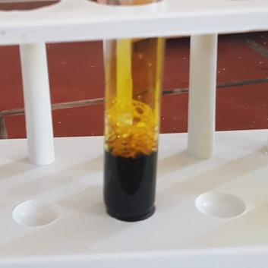 page44image30145776 page44image30144320page44image30142864

Saponins test result Phenols test result Steroids test result

page44image30135584 page44image30140576 page44image30139120

Figure 4: Phytochemical Screening Result of the Plant Extract.

### 4.1.4 Identification of the isolates

The morphological and biochemical characterization of the isolates is presented in Table 4. Both the isolates are Gram negative rods, negative for Voges Proskauer and citrate utilization test while both positive for methyl-red test. *E. coli* is motile and lactose fermenter while *Shigella* is non-motile and non-lactose fermenter.

**Table 4:** Morphological and biochemical tests for identification of the isolates

|  |  |  |  |
| --- | --- | --- | --- |
| S/N | Agar/ Biochemical test | *Escherichia coli* | *Shigella sp* |
| 1 | Nutrient agar | Whitish moist, smooth surface and opaque colony. | Translucent, opaque and glistening colony. |
| 2 | MacConkey agar | Non-mucoid dark pinkish colony. | Transparent colourless colony with jagged edge. |
| 3 | Gram staining/ shape | Negative/rod | Negative/rod |
| 4 | Indole test | + | - |
| 5 | Methyl-red test | + | + |
| 6 | Voges Proskauer test | - | - |
| 7 | Motility test | Motile | Non-motile |

**Key**: The sign (+) indicates detected while the sign (-) indicates not detected

### 4.1.5 Antibacterial activity of root bark extracts

The antibacterial activity of *Tamarindus indica* root bark extracts against *Escherichia coli* and *Shigella sp* is presented in Table 5. The result showed that methanol extract is more effective with average zone of inhibition of 13.80 mm than aqueous extract with average zone of inhibition of 8.97 mm. Based on the result, *Escherichia coli* is more sensitive to the extract than *Shigella* sp. The zone of inhibition shown by Ciprofloxacin (25 mg/mL) is 23 and 21 mm for *Escherichia coli* and *Shigella sp* respectively.

**Table 5:** Antibacterial activity of the root-bark extracts against the isolates

|  |  |  |  |
| --- | --- | --- | --- |
| Extracts | Conc. (mg/mL) | *Escherichia coli* | *Shigella sp* |
|  | 10 | 05.34±0.3 | 00.00±0.0 |
|  | 20 | 09.00±0.0 | 00.00±0.0 |
| ARE | 30 | 12.67±1.2 | 07.34±0.8 |
|  | 40 | 13.34±1.1 | 11.34±0.2 |
|  | 50 | 17.00±1.8 | 13.67±1.3 |
|  | 10 | 09.34±0.4 | 08.00±1.1 |
|  | 20 | 10.67±0.5 | 09.67±0.4 |
| MRE | 30 | 13.67±0.7 | 13.67±0.9 |
|  | 40 | 18.00±1.1 | 16.67±1.2 |
|  | 50 | 21.00±1.3 | 17.34±1.8 |
| Ciprofloxacin | 25 | 23.34±1.3 | 21.00±0.0 |

**Key:** ARE, aqueous root-bark extract; MRE, methanol root-bark extract. The value of average zones of inhibition ± Spread in millimeter (n=3).

### 4.1.6 Minimum Inhibitory Concentration (MIC) And Minimum Bactericidal Concentration (MBC)

The results for the MIC of the Aqueous and Methanol extract against *E. coli* and *Shigella sp* are presented in Table 7 and 8 respectively while Table 9 shows MBC of both aqueous and methanol extracts.

**Table 7:** Minimum Inhibitory Concentration (MIC) of *Tamarindus indica* Aqueous root bark extract against *E. coli*, and *Shigella sp*.

|  |  |  |
| --- | --- | --- |
| Concentrations (mg/mL) | *Escherichia coli* | *Shigella sp* |
| 25.000 | No turbidity | No turbidity |
| 12.500 | No turbidity | Visible turbidity |
| 06.250 | No turbidity | Visible turbidity |
| 03.125 | Visible turbidity | Visible turbidity |

The minimum Inhibitory Concentration is 6.25 mg/mL for *E. coli* and 25.00 mg/mL *Shigella sp.*

**Table 8:** Minimum Inhibitory Concentration (MIC) of *Tamarindus indica* Methanol root bark extract against *E. coli*, and *Shigella sp*.

|  |  |  |
| --- | --- | --- |
| Concentrations (mg/mL) | *Escherichia coli* | *Shigella sp* |
| 25.000 | No turbidity | No turbidity |
| 12.500 | No turbidity | No turbidity |
| 06.250 | No turbidity | No turbidity |
| 03.125 | Visible turbidity | Visible turbidity |

The minimum Inhibitory Concentration is 6.25 mg/mL.

**Table 9:** Minimum Bactericidal Concentration (MBC) of *Tamarindus indica* Aqueous and methanol extract against *E. coli*, and *Shigella sp*.

|  |  |  |
| --- | --- | --- |
| Concentrations (mg/mL) | *Escherichia coli* | *Shigella sp* |
| 12.500 | No growth | No growth |
| 06.250 | No growth | No growth |

The minimum Bactericidal Concentration is 12.50 mg/mL.

### 4.1.7 Oral Acute Toxicity Test

The oral acute toxicity test by using the limit dose of 2000 mg/kg body weight of the mouse found safe because at this dose the animals didn’t show any observable physical and behavioral changes, confirming that the LD50 of the extract is greater than 2000 mg/kg.

# CHAPTER FIVE

## 5.0 SUMMARY, CONCLUSION AND RECOMMENDATION

### 5.1 Summary

The Phytochemical screening of the *Tamarindus indica* leaves and fruits extracts indicated the presence of alkaloid, tannin, saponin, glycoside, steroid and phenols. The presence of the above phytochemicals in the plant parts was responsible for its antibacterial activity. Saponins are known to possess antibacterial activities (Gonzalez *et al.,*2009) whilst tannins play an important role in wound healing and also possess some antimicrobial activities. According to this study, Alkaloid is also present in both the extracts. Alkaloid consists of large group of nitrogenous compounds which are widely used to bind bowel in cases of diarrhea and dysentery, as anticancer anesthetics and Central Nervous Stimulants. Alkaloids are known to play some metabolic roles and control development in living system. It also interferes with cell division, hence the presence of alkaloids in the *Tamarindus indica* root bark could account for their use as antidiarrhea agents. The result of this study was inconformity with that of (Sravanthi *et al*., 2017). who reported that Results of the phytochemical studies revealed the presence of tannins, saponins, alkaloids and tri terpenoidal saponins and the extracts were active against both gram-positive and gram-negative bacteria.

The antibacterial activity of the plant showed that *Tamarindus indica* root bark extracts demonstrated an antimicrobial effect against the diarrhea causing test isolate with higher activity in methanol extract compared to aqueous extract. The methanolic extract had total zone of inhibition of 14.86 mm while 12.52 mm for *S. typhi*, while aqueous extract. This may be due to the better solubility of the active components in the organic solvent (methanol) than water which leads to better efficacy of the methanol extracts. It suggests that the active component is more soluble in ethanol than in the other solvents. However, (Doughari *et al*, 2006). stated that the antidiarrhea effect of the plant could be due to the bioactive compounds such as the phytochemicals constituent present in the plant. The results showed that the potency of the extracts on the test isolates had different hierarchy of susceptibility among the organisms. The findings of this study indicated that *E. coli* was more sensitive to the extracts with

average zone of inhibition of 13.80 mm when compared to *Shigella* with average zone of inhibition of 8.97 mm. The finding of this study supported the finding of (Nwodo *et al.,* 2011). who assessed the antibacterial activity of *Tamarindus indica* fruit pulp, stem bark and leaves extracts against some bacterial isolates. They found that the fruit pulp extracts exhibited a wide spectrum of activity; the cold-water extract against 95.5 % of the test bacterial strains; and the hot water and ethanolic extracts against 90.9 % and 86.4 %, respectively. In contrast the cold-water extract of the leaves and stem bark, each was active against 16.7 %; while the ethanolic extract of each was active against 75 % of the test strains. The minimum inhibitory Concentration of aqueous and methanol extract of the root bark showed dilutions of various concentrations of aqueous and methanol root bark extracts can inhibit the growth of the isolates at 6.25 mg/mL by methanol extract and 6.25 mg/mL for *E. coli* and 25.00 mg/mL *Shigella sp.* by aqueous extract.

### 5.2 Conclusion

From this research work it was discovered that the antidiarrhea potential of the root and stem bark of *Tamarindus indica* is attributed to classes of bioactive constituents present in the root bark of the plant such as alkaloid, tannin, saponin, glycoside, steroid and phenols which have known antidiarrheal synergically or independently. The antibacterial activities of the plant as observed in this study lend credence to the traditional claim about its antidiarrhea properties.

### 5.3 Recommendations

# REFERENCES

Aboaba, O., and Efuwape, B.M. (2001). Antibacterial properties of some Nigerian species. *Journal of Biochemical and Biophysical Research Communications*;**13**: 183-188.

Afolayan, A.J. (2003). Extracts from the shoots of *Arctotis arctotoides* inhibit the growth of bacteria and fungi. *Journal of Pharmaceutical Biology*;**41(**1**)**:22-25.

Ahmed I, Beg AZ. (2001). Antimicrobial and phytochemical studies on 45 Indian Medicinal plants against multi–drug resistance human pathogens. *J Ethnopharmacol*; **74**: 113–123.

Al-Fatimi M, Wurster M, Schroder G, Lindequist U (2007). Antioxidant, Antimicrobial and cytotoxic activities of selected medicinal plants from Yemen*.* Journal of Ethnopharmacology; **111**:657-666.

Ali M, Yahaya A, Zage AU, et al. (2017). *In–vitro* Antibacterial Activity and Phytochemical Screening of *Psidium guajava* on Some Enteric Bacterial Isolates of Public Health Importance. *Journal of Advances in Medical and Pharmaceutical Sciences*; **12**(3): 1–7.

Asl, M.N., and Hosseinzadeh, H. (2008). Review of pharmacological effects of *Glycyrrhiza* sp. And its bioactive compound. *Journal of Phytotherapy Research*;**22**(6): 709-724.

Chhabra, S.C., Mahunnah, B.L.A., Mshiu, E.N., (1987). Plants used in traditional medicine in eastern Tanzania. I. Pteridophytes and angiosperms (Acanthaceae to Canellaceae). Journal of Ethnopharmacology; **21**: 253–277.

Chitme HR, Chandra R, Kaushik S. (2004). Studies on antidiarrhoeal activity on *Calotropis gigantean* R.BR. In experimental animals. J Pharm Pharm Sci; **7**: 70-5.

Chung, K.T., Wong. T. Y., Wei, C.I., Huang, Y.W., and Lin, Y. (1998). Tannins and human health: a review. *Critical Reviews in Food Science and Nutrition*;**38**(6): 421-464.

Congesta W.T.C (2005). Preliminary screening of some folklore medicinal plants from a Preliminary screening of some folklore medicinal plants from 70 Western India for potential antimicrobial activity eastern India for potential antimicrobial activity. *Indian Journal of Pharmacology*;**37**(6): 408-409.

Cowan, M.M. (1999). Plant products as antimicrobial agents. *Journal of Clinical Microbiology Reviews*; **12**(4): 564-582.

Cushnie, T.T. and Lamb, A.J (2014). Alkaloids: an overview of their antibacterial, antibiotic enhancing and antivirulence activities. *International Journal of antimicrobial agents*;**44**(5): 377-386.

Cushnie, T.T. and Lamb, A.J (2005). Antimicrobial activity of flavonoids. *International Journal of Antimicrobial Agents*;**26**(5): 343-356.

Cushnie, T.T. and Lamb, A.J (2011). Recent advances in understanding the antibacterial properties of flavonoids. *International Journal of antimicrobial agents*;**38**(2): 99-107.

Dalziel, J.M., (1937). **The Useful Plants of West Tropical Africa. Crown Agents for the Colonies, London.**

Deshpande, S., Kewatkar, S., and Paithankar, V. (2013). Antimicrobial activity of Saponins rich fraction of *Cassia auriculate Linn* against various microbial strains. *International Current Pharmaceutical Journal*;**2**(4): 85-87.

Doughari J.H. (2006). Antibacterial activity of Tamarindus indica linn. *Trop J Pharm*; **5**(2): 597–603.

El-Siddig, K., Ebert, G., Lüdders, P. (1999). *Tamarind* (*Tamarindus indica* L.): *A Review on a Multipurpose Tree with Promising Future in the Sudan.* Journal of Applied Botany– Angewandte Botanik; **73**: 202-205.

Fabricant, D.S., and Farnsworth, N.R. (2001). The value of plants used in traditional medicine for drug discovery. *Journal of Environmental Health Perspectives*; **109**(1): 65-69.

Faulkner, J.R., Hussaini, S.R., Blankenship, J.D., Pal, S., Branan, B.M., Grossman, R.B., and Schardi, C.L. (2006). On the sequence of bond formation in loline alkaloid biosynthesis. *Journal of Chemistry and Biochemistry*; **7**(7): 1078-1088.

Freiburghaus, F., Kaminsky, R., Nkunya, M.H.H., and Brun, R. (1996). Evaluation of African medicinal plants for their in vitro trypanocidal activity. *Journal of Ethnopharmacology*;**55**(1): 1-11.

Galeotti, F., Barile, E., Curir, P., Dolci, M., and Lanzotti, V. (2008). Flavonoids from carnation (*Dianthus caryopyllus*) and their antifungal activity. *Journal of Phytochemisty Letters*;**1**(1): 44-48.

Garba, S., and Okeniyi, S.O. (2012). Antimicrobial activities of total alkaloids extracted from some Nigerian medicinal plants. *Journal of Microbiology and Antimicrobial Agents*;**4**(3): 60-63

Ghoshal, S., Prasad, B.K., and Lakshimi, V. (1996). The antiamoebic activity of *Piper longum* fruits against *Entamoeba histolytica in vitro and in vivo*. *Journal of Ethnopharmacology*;***50***(3): 167- 170.

Gonzalez–Lamothe R, Mitchell G, Gattuso M. (2009). Plant antimicrobial agents and their effects on plant and human pathogens. *J Mol Sci*; **10**:3400–3419.

Gutiérrez, R.M.P., Mitchell, S., Solis, R.V., (2008). Psidium guajava: a review of its traditional uses, phytochemistry and pharmacology. Journal of Ethnopharmacology; **117**: 1–27.

Hill, A.F. (1952). Economic Botany: **A Textbook of Useful Plants and Plants Products** (No. SB103, H54 1937).

Holzmuller, P., Sereno, D., Cavaleyra, M., Mangot, I., Daulouede, S., Vincendeau, P., and Lemesre, J.L. (2012). Nitric oxide-mediated proteasome-dependent oligonucleosomal DNA fragmentation in *Leishmania amazonensis* amastigotes. *Journal of infection and immunity*;**70**(7): 3727-3735.

Hambidge, M. (2006). Human zinc deficiency. Journal of Nutrtion, 130:1344S-1349S.

<http://www.traffic.org/medicinal-plants> (30th May, 2014).

<http://www.microbiologyinfo.com/biochemical-test> (15th June, 2014).

Joshi, N.U.P.U.R., Bhatt, S.H.A.N.K., Dhyani, S., and Nain, J.Y.O.T.I. (2013). Phytochemical screening of secondary metabolites of *Argemone Mexicana* Linn. Flowers. *International Journal of Current Pharmaceutical Research*;**5**(2): 144-147.

Kanth, S, V., Venba, R., Madhan, B., Chandrababu, N. K., and Sadulla, S. (2009). Cleaner tanning practices for tannery pollution abatement: the role of enzymes in eco-friendly vegetable tanning. *Journal of Cleaner Production*;**17(**5**)**:507-515.

Keita, A., Coppo, P., (1993). Plantes et Remedes du Plateau Dogon. CRMT, Bandiagara, Mali, pp. 19- 31.

Kerharo, J., Bouquet, A., (1950a). Plantes Médicinales et Toxiques de la Côte d’Ivoire et Haute- Volta. Vigot Freres, Paris.

Kittatoop, P., Mahidol, C., and Ruchirawat, S. (2014). Alkaloids as important scaffolds in therapeutic drugs for the treatment of cancer, tuberculosis, and smoking cessation. *Journal of Current Topics in Medicinal Chemistry*;**14**(2): 249-252.

Kobayashi A, Adenan MI, Kajiyama S., (1996). A Cytotoxic Principle of *Tamarindus indica*, din- butyl maleate and the Structure-activity Realationship of its Analogues. Z Naturforch; **51**(3- 4):233-242.

Kokwaro, O., (1976). Medicinal Plants of East Africa. East African Literature Bureau, Kampala, Nairobi, Dar es Salaam.

Krishnaraju, A.V., Rao, T.V., Sundararaju, D., Vanisree, M., Tsay. H.S., and Subbaraju, G.V. (2005). Assessment of bioactivity of Indian medicinal plants using brine shrimp (*Artemiasalina*) lethality assay. *International Journal for Applied Science Engineering*;**3**(2): 125-340.

Leonard J. Genera des, (1957). Cynometereae et des Amherstie africaines Leguminosae Caesalpinioideae. Memoire Academie Royale Belgique; **30**:1–314. [[Google Scholar](https://scholar.google.com/scholar_lookup?journal=Memoire+Academie+Royale+Belgique&title=Genera+des+Cynometereae+et+des+Amherstie+africaines+Leguminosae-Caesalpinioideae&author=J+Leonard&volume=30&publication_year=1957&pages=1-314&)]

Li, R., Wang, M.Y., and Li, X.B. (2012). Chemical constituents and biological activities of genus Hosta (Liliaceae). *Journal of Medicinal Plants Research,* **6**(14), 2704-2713. 76.

Lichterman, B.L. (2004). Book: aspirin: the story of a wonder drug. *BMJ: British Medical Journal*;**329**(7479): 1404-1408.

Longanga OA, Vercruysse A, Foriers A., (2000). Contribution to the ethnobotanical, phytochemical and pharmacological studies of traditionally used medicinal plant in the treatment of dysentery and diarrhea in Lomela area, Democratic Republic of Congo, (DRC). J Ethnopharmacol; **71**:411-23.

Lopes, G.K., Schulman, H.M and Hernes-Lima, M. (1999). Polyphenol tannic acid inhibits hydroxyl radical formation from Fenton reaction by complexing ferrous ions. *Biochemica et Biophysica Acta (BBA)-General Subjects*;**1472**(1): 142-152.

Maatalah, M.B., Bouzidi, N.K., Bellahouel, S., Merah, B., Fortas, Z., Soulimani, R., and Derdour, A. (2012). Antimicrobial activity of the alkaloids and saponin extracts of *Anabasis articulate. Journal of Biotechnology Pharmaceutical Research,* **3**(3): 54-57.

McNaught, A.D. (1997). Compendium of chemical terminology (Vol. 1669). Oxford: Blackwell Science.77.

Mishra RN. Tirupathi. India (A.P). (1997). Jun 27-28, ‘*Tamarindus Indica* L: An Overview of Tree Improvement’, Proceedings of National Symposium on *Tamarindus indica* L; organized by Forest Dept. of A.P., India.

Morton F. (1958). Julia.Tamarind (Tamarindus indica L.) its food, medicinal and Industrial uses, Florida State Horticultural society: 222-288.

Nascimento, G.G., Locatelli, J., Freitas, P.C., and Silva, G.L. (2000). Antibacterial activity of plant extracts and phytochemicals on antibiotic-resistant bacteria. *Brazilian Journal of Microbiology*;**31**(4): 247-256.

Nwodo U.U., Obiiyeke G.E., Chigor V.N. (2011). Assessment of Tamarindus indica extracts for Antibacterial Activity. *Int J Mol Sci*; **12**(10): 6385– 6396.

Okoli AS and Imegbu IU. (2004). Evaluation of attract of anthocleista dzalonensi, nauclea latitalia and uvaria atzali for activity against bacterial isolates from laces of non–gonocial urethritis. *Journal of ethnolphamalogy*; **92**(1): 135–144.

Oksman-Caldenteya, K. and Inze D. (2004). Plant cell factory in the post-genomic era: new ways to produce designer secondary metabolites. Trends in plant science; **9**(9): 433-440.

Okwu, D.E. (2004). Phytochemicals and vitamin content of indigenous spices of South Eastern Nigeria. *Journal for Sustainable Agriculture Environment*;**6**(1): 30-37.

Ramakrishnan, K., Selvi, S.R., and Shubha, R. (2006). Tannin and its analytical techniques. *Indian Journal of Chemical Engineering*;**48**(2): 88. 79.

Riguera, R. (1997). Isolating bioactive compounds from marine organisms. *Journal of Marine Biotechnology*;**5**: 187-193.

Rupasinghe, H.V., Jackson, C.J.C., Poysa, V., Di Berardo, C., Bewley, J.D., and Jenkison, J. (2003). Soyasapogenol A and B distribution in soybean (Glycine max L. Merr.) in relation to seed physiology, genetic variability, and growing location. *Journal of Agricultural and Food Chemistry*;**51**(20): 5888-5894.

Sano M, Miyata E, Tamano S, *et al*., (1996). Lack of Carcinogenicity of Tamarind Seed polysaccharide.in B6C3F1 Mice. Food Chemical Toxicology; **34**(5): 463-467.

Schardl, C. L., Grossman, R.B., Nagabhyru, P., Faulkner, J.R., and Mallik, U.P. (2007). Loline alkaloids: currencies of mutualism. *Journal of Phytochemistry*;**68**(7): 980-996.

Shahzadi, I., Hassan, A., Khan, U.W., and Shah, M.M. (2010). Evaluating biological activities of the seed extracts from *Tagetes minuta L.* found in Northern Pakistan. *Journal of Medicinal Plants Research*;**4(**20**)**: 2108-2112. 80

Simitu, P., Oginosako, Z., (2005). Socio-economic survey of Adansonia digitata and Tamarindus indica in Kitui. In: Simitu, P. (Ed.), Utilization and Commercialization of Dryland Indigenous Fruit Tree Species to Improve Livelihoods in East and Central Africa. Proceedings of a Regional Workshop, KEFRI, ICRAF ECA. Kitui, Kenya: pp. 14–22.

Solomon Charlse Ugochukwu, Arukwo Uche and Onuoha Ifeanyi (2013). Preliminary phytochemical screening of different solvent extracts of stem bark and root of Dennetic tripetala G. Baker. *Asian journal of plant science and research*;**3**(3): 10-13.

Soong, Y-Y., Barlow, P.J. (2004). *Antioxidant activity and phenolic content of selected fruit seeds.* Food Chemistry; **88**: 411-417.

Srivastava, J., Lambert, J., and Vietmeyer, N. (2005). Medicinal plants: An expanding role in from Western India for potential antimicrobial activity. *Indian Journal of Pharmacology*;**37:** 406 409.

Siddhuraju, P. (2007). *Antioxidant activity of polyphenolic compounds extracted from defatted raw and dry heated Tamarindus indica seed coat.* LWT; **40**: 982-990.

Siddhuraju, P., Vijayakumari, K., Janardhanan, K. (1995). *Nutritional and Antinutritional Properties of the Un- derexploited Legumes Cassia laevigata Willd. and Tamarindus Indica* L. Journal of Food Composition and Analysis; **8**: 351-162.

Sravanthi T., Kavita W., Subba R. D. (2017). Phytochemical screening and anti–microbial and anti–oxidant studies of dehydrated tender tamarind (Tamarindus indica) leaves. *International Journal of Food Science and Nutrition*; **2**(1): 62–64.

Tsuda, T., Watanabe, M., Ohshima, K., Yamamoto, A., Kawakishi, S., Osawa, T. (1994). *Antioxidative Components Isolated from the Seed of Tamarind (Tamarindus indica* L.*).* Journal of Agricultural and Food Chemistry; **42**: 2671-2674.

Ververidis, F., Trantas, E., Douglas, C., Vollmer, G., Kretzschmar, G., and Panopoulos, N. (2007). Biotechnology of flavonoids and other phenylpropanoid-derived natural products. Part I: Chemical diversity, impacts on plant biology and human health. *Journal of Biotechnology*;**2**(10): 1214-1234.

Victora CG, Bryce J, Fontaine O, Monasch R. (2000). Reducing deaths from diarrhea through oral rehydration therapy. Bull World Health Organ; **78**(12): 46-55.

Yokosuka, A., and Mimaki, Y. (2009). Steroidal saponins from the whole plants of *Agave utahensis* and their cytotoxic activity. *Journal of Phytochemistry*;**70**(60): 807-815.

Zamora-Ros, R., Agudo, A., Luján-Barroso, L., Romieu, I., Ferrari, P., Knaze, V., and Sánchez Cantelejo, E. (2012). Dietary flavonoid and lignan intake and gastric adenocarcinoma risk in the European Prospective Investigation into Cancer and Nutrition (EPIC) study. *The American Journal of Clinical Nutrition*; **96(**6**)**: 1398-1408.

Zohrameen S*, Mujahid M, Bagga P, Khalid M, Noorul H, Nesar A, Saba (2017) P. Faculty of Pharmacy, Integral University, Dasauli, Kursi road, Lucknow-226026, Uttar Pradesh, India.